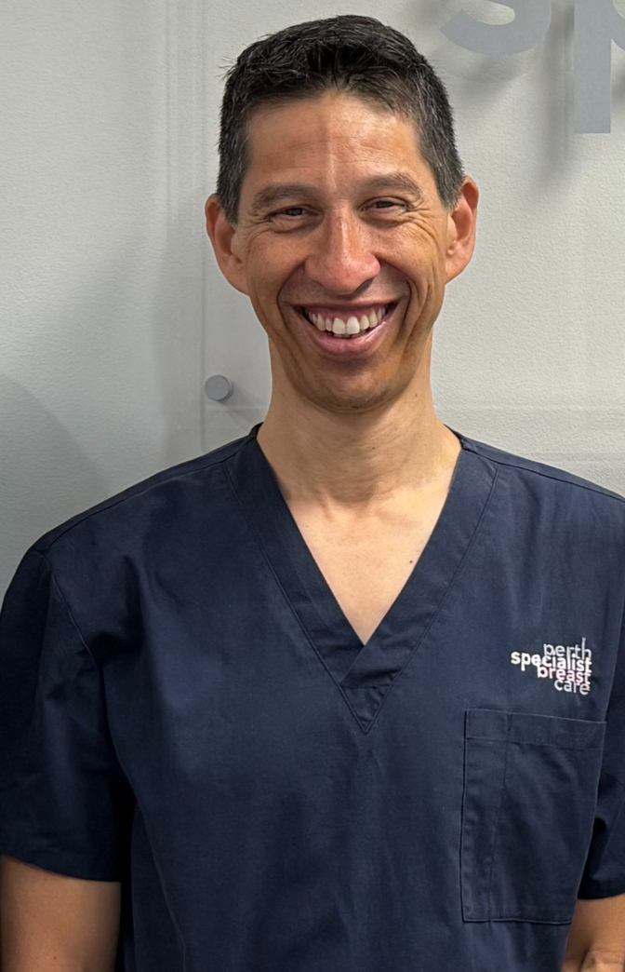
Mr Lee Jackson
MBBS (Melb); FRACS
Specialist Oncoplastic Breast surgeon

- 1992- MBBS, University of Melbourne
- 2003- Fellow of Royal Australasian College of Surgeons (General Surgery)
- 2003-2004 Inaugural Fellow Breast Surgery, Royal Perth Hospital
- 2007-2011 Clinical Associate Professor, Professorial Breast Surgical Unit, Nottingham City Hospital, UK
- 2013- 2021 Head of Multidisciplinary Breast Service South Metropolitan Health Service (Royal Perth and Fiona Stanley Hospitals)
- 2016- Current Sessional Breast Oncoplastic Surgeon, Fiona Stanley Hospital

After completing his General Surgery training (2003), Lee commenced his Fellowship in Breast Surgery at Royal Perth Hospital as their Inaugural Fellow, under the mentorship of pre-eminent Perth Surgeons Prof. Christobel Saunders (AO) and Mr Peter Willsher.

He then successfully undertook Advanced Breast Surgical Training at Nottingham University Hospitals NHS Trust (UK) under the leadership of esteemed Plastic Surgeons including the past president of the British Association of Plastic, Reconstructive and Aesthetic Surgeons Mr Graeme Perks (FRCS, FRACS). Under his tutelage, Lee further developed and refined his breast surgical and microsurgical skills in both novel and traditional partial and complete Breast Oncoplastic Reconstructions, including pre-pectoral and flap reconstructions (ie. Grisotti and local perforator flaps) and procedures such as Goldilocks, lipofilling and mastopexy. He is also skilled with a range of lymph node surgeries including sentinel node biopsies and targeted axillary dissections.

Upon returning to Perth in 2007, Lee returned to Royal Perth Hospital, becoming the Head of Breast Service (2013) and then the Head of Multidisciplinary Breast Service position at Fiona Stanley Hospital (2014). In 2015, Lee joined Prof. Saunders and Dr Wen Chan Yeow in the private sector to form Perth Special Breast Care at SJOG Subiaco, to deliver a multidisciplinary breast service focusing on providing high quality holistic patient centred care.

Lee has continued with this vision and remains committed to providing a comprehensive and seamless service from start to finish. He invests much time to ensure he practices at the top of his field, implementing and translating the latest breast surgery and breast cancer treatment evidence to clinical practice. He enjoys spending time with his patients, competently guiding them with their surgical and treatment decision making and care needs. Surgically he is known to be meticulous with his work to ensure optimal aesthetic outcomes, whilst also being attentive to other important needs of his patients, including functional needs and priorities.

With over 20 years of experience after specialising as a breast surgeon, Lee continues to mentor the next generation of doctors undertaking their Breast Surgical Fellowships/ Training in the public sector. He also actively pursues emerging practice investigating the feasibility of Endoscopic and Robotic Breast Surgery. Lee sees patients at SJOG Subiaco, SJOG Murdoch, Genesis Joondalup (?) and will soon commence consulting at SJOG Midland.

